Guidelines for submission of proposals
The Image Conference, 6th & 7th October 2018, Athens, Greece
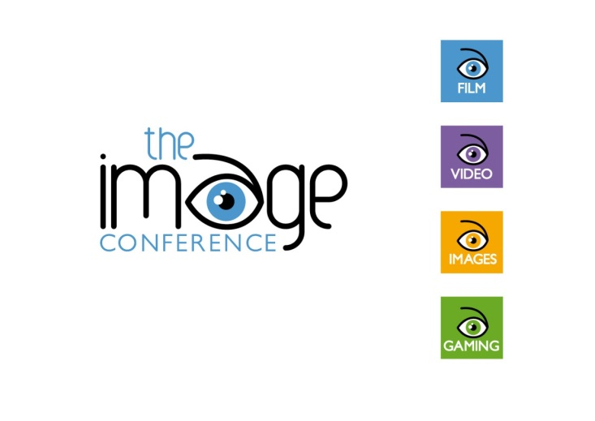

Thank you for wanting to submit a speaker proposal for The Image Conference 2018, Athens, Greece.
We would appreciate it if you would take a moment to read through these submission of proposals guidelines to help you, us and the delegates get the most out of the conference.

The deadline for proposals is Friday 8th June. Notification of acceptance of proposals will take place on Friday, 6th July. Once you have been accepted to speak, you will receive a provisional acceptance email.
Prospective speakers for the conference are kindly asked to submit abstracts for talks or workshops – 50 words maximum. All proposals must be related to the use of images in language teaching and learning. Topics can include:
- images
- video
- film
- gaming
- art
- mental imagery
- virtual reality and
- augmented reality.
As Greece is at the epicentre of the refugee crisis in Europe, we encourage proposals related to using images when teaching English to refugees and/or when teaching about refugees through English.
Proposals should be chosen in line with the following presentation categories:
• Workshop (45 minutes, including questions): A workshop is a session in which there is active audience participation via the experiencing and discussing of tasks provided by the presenter.
• Talk (45 minutes, including questions): A talk tells the delegates something about teaching English through images.
Please submit your title (maximum 10 words), abstract (maximum 50 words), and bio-data (maximum 50 words).
Are you speaking on behalf of a publisher or institution?
If so, please make this very clear. Delegates are likely to be disappointed if a session they attended based on the description in the abstract turns out to be an advertisement for a publication, product, or course. The submissions of speaker proposals for commercial presentations are welcomed but, if you are basing your presentation either in part or in full on a newly or recently published material, you should clearly say this in your abstract.
Is the information in your abstract clear?
Be explicit about whether you are offering a talk, a hands-on workshop or a commercial presentation. We want to be sure that when delegates register for sessions, they can do so on the basis of accurate information.
Please submit your proposal by completing the proposal submission form by Friday 8th June 2018.

