Guidelines for Speakers
The Image Conference, Munich 5th December 2015
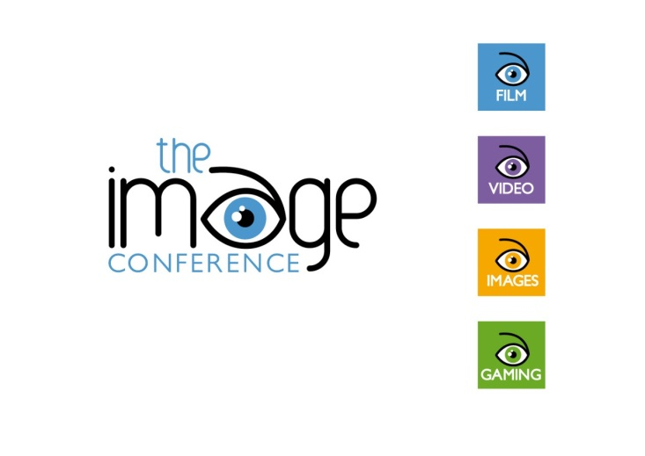
Thank you for wanting to submit a speaker proposal for The Image Conference 2015, Munich, Germany.
We would appreciate it if you would take a moment to read through these speaker guidelines to help you, us and the delegates get the most out of the conference. The conference will take place at the Gasteig, Munich, on Saturday, 5th December 2015. In total we will be accepting 15 proposals (talks and workshops). There will be five 60-min slots with three parallel sessions each.
If more proposals are received, some will, unfortunately, have to be rejected. The events team will be in touch to confirm whether or not your proposal has been successful. The deadline for proposals is Tuesday, 30th June. Notification of acceptance of proposals will take place on Friday, 27th July. Once you have been accepted to speak, you will receive a provisionary acceptance email.
Prospective speakers for the conference are kindly asked to submit abstracts for talks or workshops – 60 words maximum. All proposals must be related to the use of images in language teaching and learning. Topics can include:
- images
- video
- film
- gaming
- art
- mental imagery.

Proposals should be chosen in line with the following presentation categories:
• Workshop (60 minutes, including questions): A workshop is a session in which there is active audience participation via the experiencing and discussing of tasks provided by the presenter.
• Talk (60 minutes, including questions): A talk tells the delegates something about teaching English through images.
Please also submit your bio-data (50-70 words).
Are you speaking on behalf of a publisher or institution?
If so, please make this very clear! Delegates are likely to be disappointed if a session they attended based on the description in the abstract turns out to be an advertisement for a publication, product, or course. The submissions of speaker proposals for commercial presentations are welcomed but, if you are basing your presentation either in part or in full on a newly or recently published material, you should clearly say this in your abstract.
Is the information in your abstract clear?
Be explicit about whether you are offering a talk, a commercial presentation or a hands-on workshop. We want to be sure that when delegates register for sessions, they can do so on the basis of accurate information.

